**Assignment On Spring Core**

1. Create an Address class with the following attributes:- street, city, state, zip, country Create an Customer class with the following attributes:- customerId, customerName, customerContact, customerAddress.

Inject the Address bean into Customer bean using setter injection Create a Test class with main() method, get Customer bean from ApplicationContext object and print details of Customer.

Also write the JUnit Test cases for above program. - Modify the above application and inject the bean using constructor injection - Use XML based Configuraion

Address Class

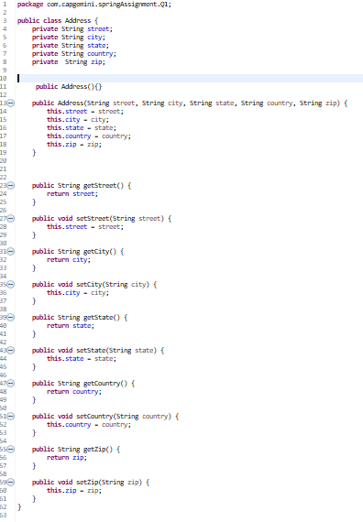

Customer Class

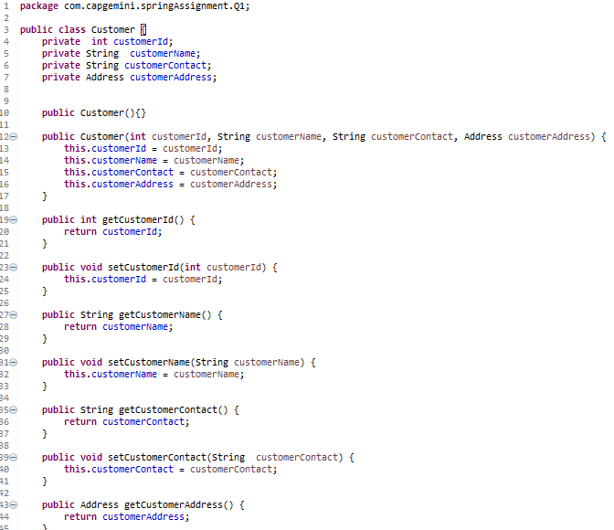

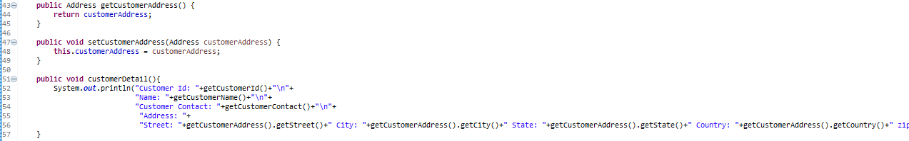

Test Class

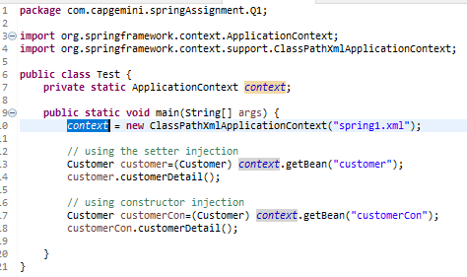

Output

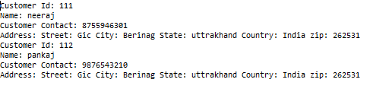

2) Example of Injecting collections (List, Set and Map) Create a class Question with following attributes: questionId, question, answers. There are 3 cases for above program. a. Write a program where answers is of type List or String [] b. Write a program where answers is of type Set c. Write a program where answers is of type Map In case of Map, Integer value represents answer’s sequence number. d. Create a Test class with main() method, get Question bean from ApplicationContext object and print question and its answers. e. Also write the JUnit Test cases for above program. - Use XML based configuration.

Question Class

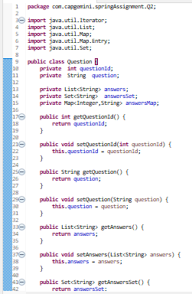

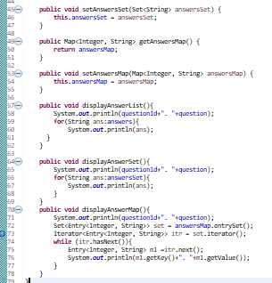

Test Class

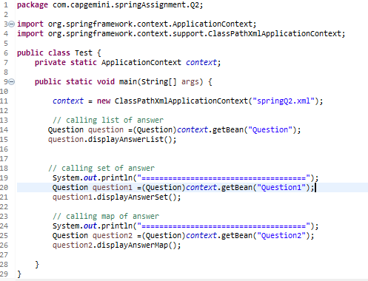

XML file

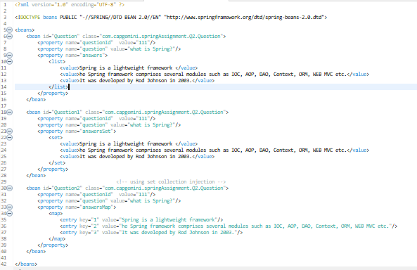

Output

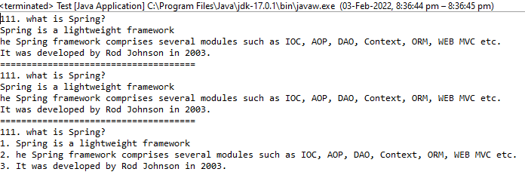

3) Example on autowiring Design and Develop a Banking Application as follows:

a. Create a BankAccount class with following attributes: accountId, accountHolderName, accountType, accountBalance

b. Create an interface BankAccountRepository with following methods: public double getBalance(long accountId) public double updateBalance(long accountId, double newBalance): Note: Above method returns updated balance.

c. Create a class BankAccountepositoryImpl that implements BankAccountRepository interface. You can use database or any collection object as persistence store.

d. Create an interface BankAccountService with following methods: public double withdraw(long accountId, double balance) public double deposit(long accountId, double balance) public double getBalance(long accountId) public boolean fundTransfer(long fromAccount, long toAccount, double amont)

e. Create a class BankAccountServiceImpl that implements BankAccountService interface.

f. Create a class BankAccount controller with following operations: public double withdraw(long accountId, double balance) public double deposit(long accountId, double balance) public double getBalance(long accountId) public boolean fundTransfer(long fromAccount, long toAccount, double amont)

g. Create a Test class with main() method, get BankAccountController bean object from ApplicationContext and perform all the operations.

h. Also write the JUnit Test cases for above program. - Use XML based configuration and perform autowiring with different types. (byName, byType and constructor). Use one autowiring type at a time.

Class Bank Account

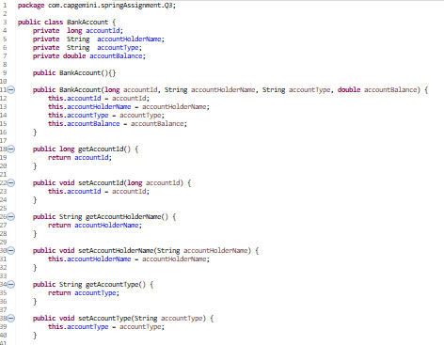

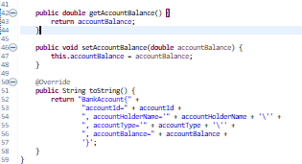

Interface BankAccountRepository

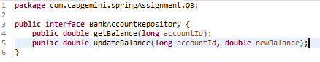

Class BankAccountepositoryImpl

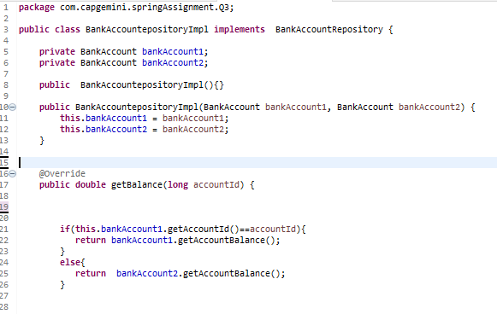

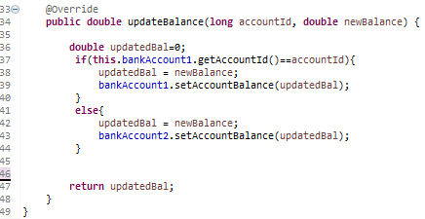

Interface BankAccountService

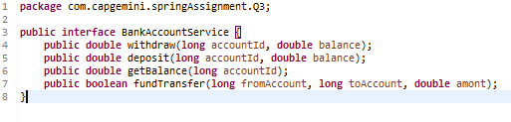

Class BankAccountServiceImpl

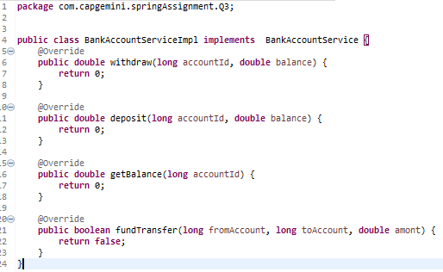

Class BankAccountController

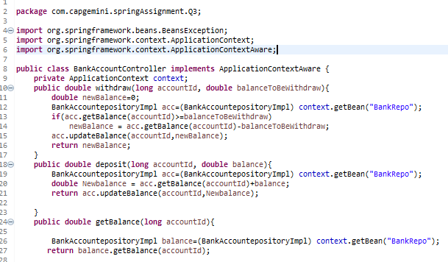

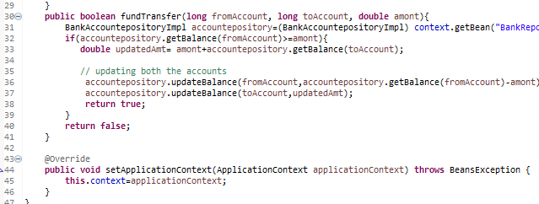

Class Test

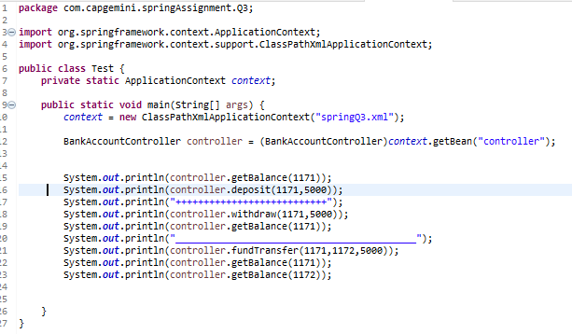

Spring XML file

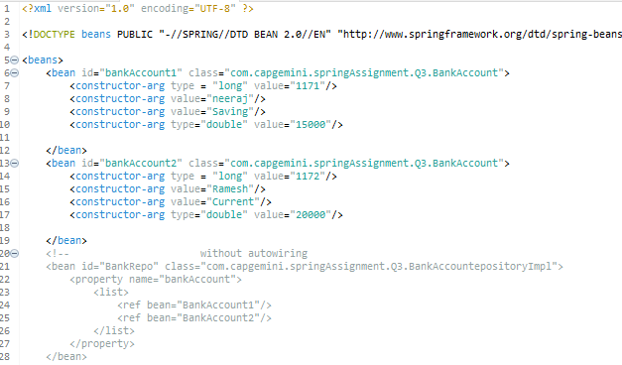

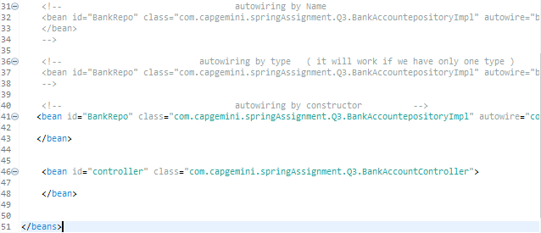

Output

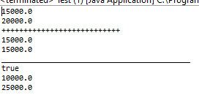

5) Write a program to demonstrate use of @Resource, @Inject, @Required annotations

6) Example of @Component, @Value, @PropertySource & Environment

a. Create a dbConfig.properties file which contains database configuration details like driver class name, dburl, username, password.

b. Create a Java class in which you have to read all properties and display on a console. (Use @Component, @Value or Environment and @PropertyResource).

7) Write a Java program to demonstrate SPEL (Spring Expression language)

Code

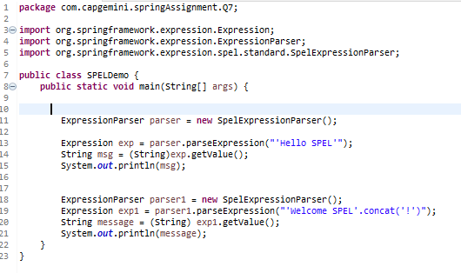

Output



8) Write a Java program to demonstrate InitializingBean and DisposableBean.

Try Different ways:

(Use init-method and destroy-method in xml config file)

(Use @PostConstruct and @PreDestroy)

9) Write a Java program to demonstrate Complete Bean Life cycle.

Class BeanLifeCycle

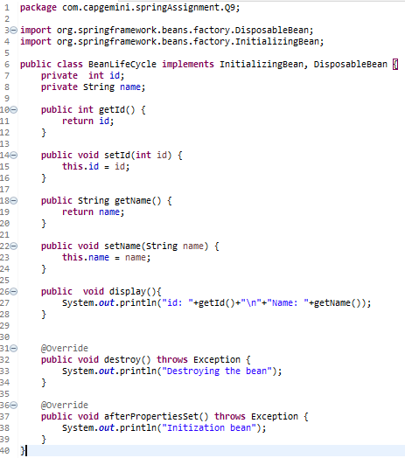

Class Test

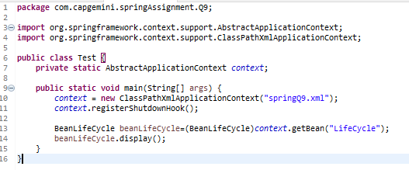

Output

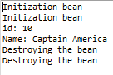

10) Write a java program to demonstrate ApplicationContextAware interface.

Class ContextAwareExample

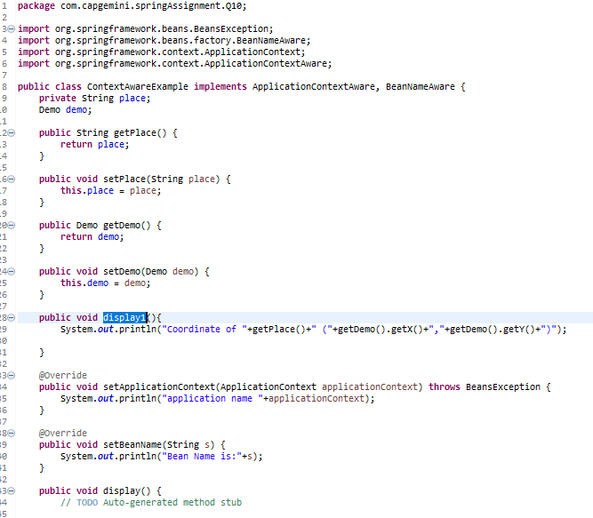

Demo Class

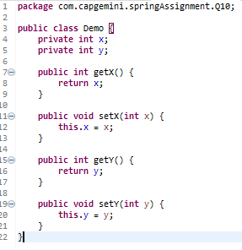

Test Class

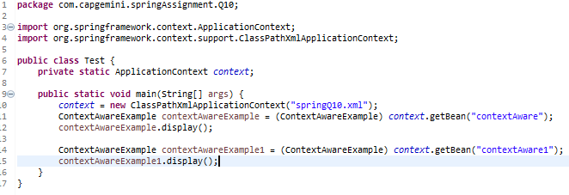

Output



4) Example on @Controller, @Service, @Repository, @Autowired, @Configuration and @Bean Modify the above application, use annotations and java based configuration

Class Bank Account

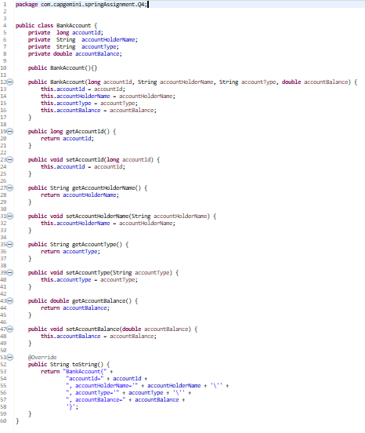

Interface BankAccountRepository

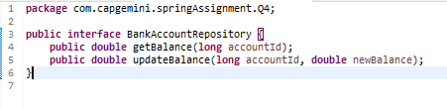

Class BnakAccountepository

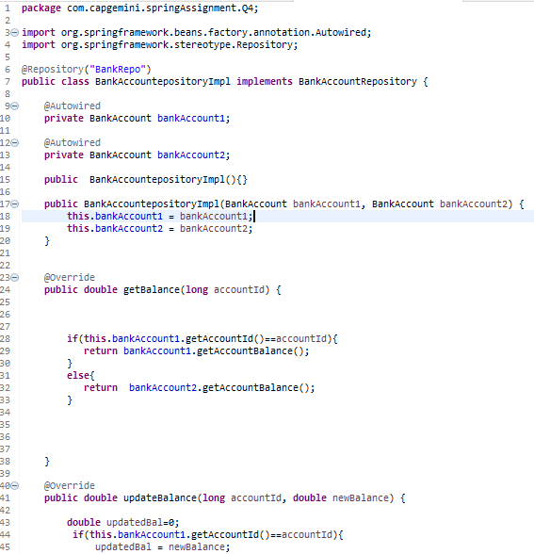

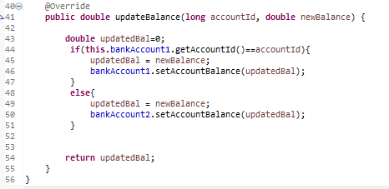

Creating Interface

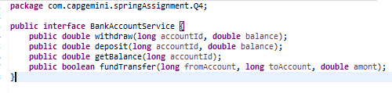

Class BankAccountServiceImpl

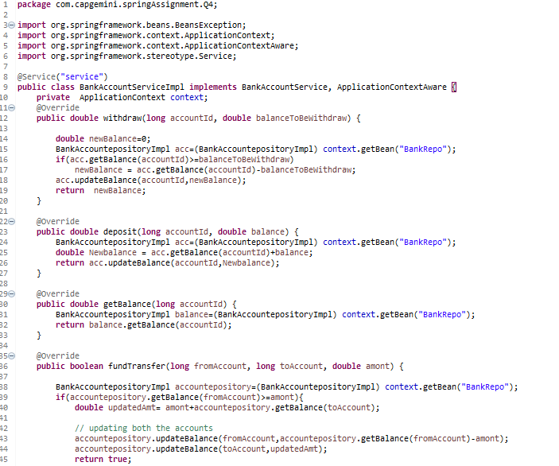

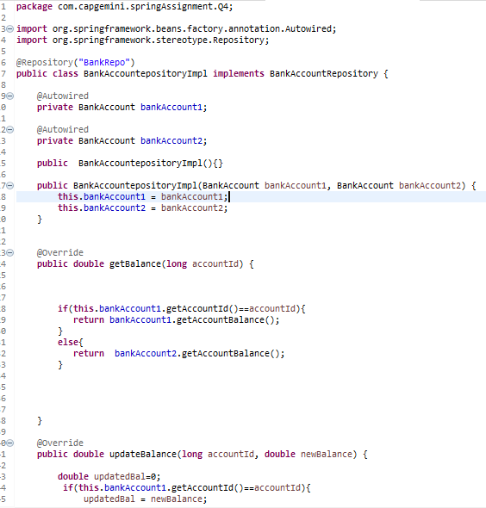

Output

